**Exp 6 DESIGN AN OBSTACLE DETECTOR AND DISTANCE MEASURING DEVICE**

**Circuit Diagram**

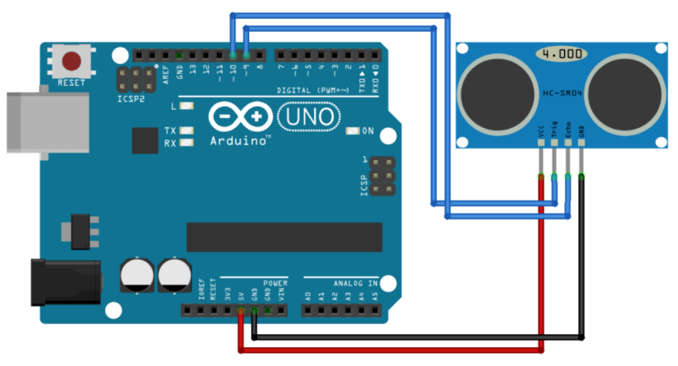

**Theory**

**Concepts Used**

1. Interfacing The Ultrasonic sensor with the Arduino and leds.
2. Blinking Of Leds concept used.
3. Concept of Condition Statement used.
4. Concept of digitalread used.

**Learnings and Observations**

In this experiment we learnt the following:

1. Basic circuit building with Arduino uno.
2. Interfacing an LED with Arduino uno.
3. Interfacing a ultrasonic sensor with led and Arduino.
4. Working and principle of ultrasonic sensor.

We observe the following things:

1. When we bring our hand closer to the sensor and move apart our hand from the sensor it gives the distance between our hand and the sensor.
2. By changing into the code we observe that when we bring our hand less than 2cm the led start glowing and it gives 100% brightness and then slowly it will off.

**Precautions**

1. Don’t make the connection loose.
2. Before uploading the code into the Arduino make sure that the circuit is correct to avoid the damage of the circuit
3. Check the leds are working or not with the help of the multimeter.
4. The LED should not be connected in reversed direction because it doesn’t allow passing the current and circuit does not completed and LED will not glow.
5. Make sure that the sensor is working properly.

**Learning Outcomes**

1. **We learn that how we can calculate the distance between the two object.**
2. **We also learn that how to use ultrasonic sensor with the aurdino and led.**
3. **We also get to know the function of the “microsecond”.**
4. **We also get to know the applications of the ultrasonic sensor.**
5. **We also learn the principle of ultrasonic sensor.**